Description of the Product
30 HP ELECTRIC OUTBOARD MOTOR

SEAGÖ SE30 is an electric outboard motor has a rated voltage of 96V, and the maximum power is 22 kW. Compared to the existing gasoline models, the electric outboard is quieter and more environmentally friendly because they run on electricity instead of fuel. Additionally, we use Permanent Magnet Synchronous Motors, which have reduced noise, extended lifespan, increased efficiency and require less maintenance.
Relevant Boat Class
Small vessels of various materials including inflatable boats, wooden boats, FRP boats, plastic boats and similar, with lengths ranging from 4 Metres above, are a good fit for the electric 30-horsepower outboard motor.
Recommended Battery
For this Model, 96V 230 AH LiFePO4 – Lithium Ferrous Phosphate battery packs can be utilized
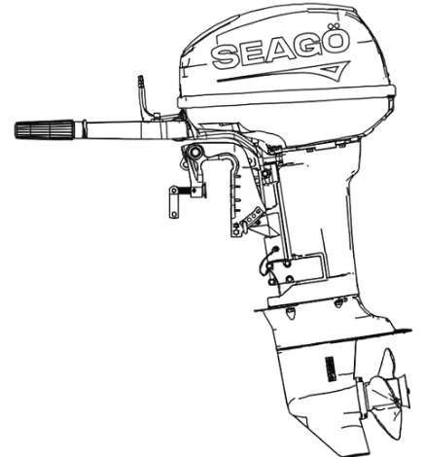

Specifications

Product Model | SE30
Voltage / Power | 96V / 22 kW
Motor Type | Water cooled PMSM
Rotating Speed | 5800r/min
Max.conti. current | 230A
Max.power. consumption | 230AH
Speed control | Infinitely variable speed
Cruise | Available
Gear shift | Forward / Reverse(Switch)
Cooling System | Water Cooling
Tilt & Trim | Manual
Propeller | 9 7/8 * 12
Power display | Available
Recommended Stern Height | 550mm
Weight {Kg} | 52.7 Kgs

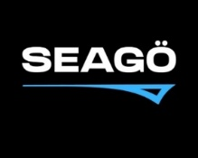
www.seago.in sales@seago.in +91-8606366633
30 HP ELECTRIC OUTBOARD MOTOR

